

Swarmed Parallel Interpreter for Numerical Analysis with Collaborating Hubs
CSE 784 – Software Studio
B - Specification
version 1.3
18th November, 2009

By:

Abhay Ketkar
Arun Kumar Kyasaralli
Prateek Jain
Rutu Pandya

Contents
1. Reference Documents 3
2. Requirements 4
2.1. Functional Requirements 5
2.1.1. Connection Process 5
2.1.1.1. inputs 5
2.1.1.2. processing 5
2.1.1.3. outputs 5
2.1.2. Program Configuration 6
2.1.2.1 inputs 6
2.1.2.2 processing 6
2.1.2.3 outputs 6
2.1.3. Chatting 6
2.1.3.1 Input 6
2.1.3.2 Processing 7
2.1.3.3 Output 7
2.1.4. Display 7
2.1.4.1 Program Editing 7
2.1.4.1.1 Input 8
2.1.4.1.2 Processing 8
2.1.4.1.3 Output 8
2.1.4.2 Show Results 8
2.1.4.2.1 inputs 8
2.1.4.2.2 processing 9
2.1.4.2.3 outputs 9
2.1.4.3 Show Errors 9
2.1.4.3.1 inputs 9
2.1.4.3.2 processing 9
2.1.4.3.3 outputs 9
3 Data Dictionary 10
4 Requirements Traceability Matrix 11

Reference Documents
- PINAC Draft A-Level Specification, Version 1.0 by Phil Pratt-Szeliga
- Architectural Concept Document by Yehong Wang

Requirements
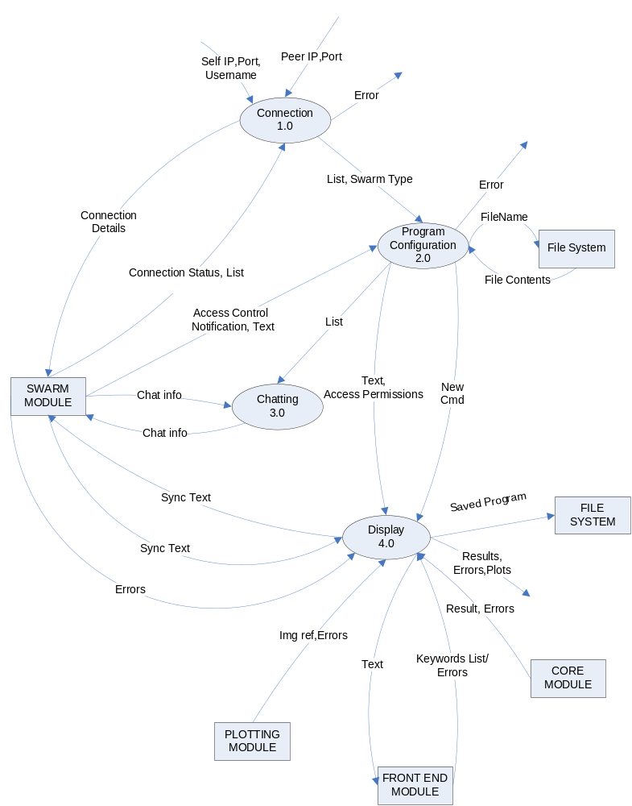
Figure 1 - Data Flow Diagram 1

The Execution of SPINACH’s UI is divided into 3 major processes, Connection, Program Configuration and Display.

Functional Requirements
These sections describe the activities required of the SPINA program.
These sections describe the activities required of the SPINA program.

Connection Process
The Connection process is responsible for allowing users to create a new swarm or join an existing swarm.

inputs
- The Self IP, Port and Username that is to be used for connecting to the swarm.
- Peer IP and Port to which the user wants to connect.
- The Connection Status/List of users in the swarm to which the user has connected.

processing
The Connection process shall provide a text box initially containing the IP of the machine and a default port number. It shall also provide the functionality to change these details. It shall provide a text box to accept the Username. After entering these, the user may choose to create a new Swarm, or Join an existing Swarm, and radio buttons shall be provided for the same. To join a swarm, it shall provide 2 more text boxes to accept the details of the peer to which the user wants to connect. It shall send the connection details to the Swarm module. It shall receive a list of peers connected in the Swarm and forward it to the Program Configuration process. The Connection process shall report any connection errors to the user.

outputs
- The Connection details that are to be used for connecting to a swarm.
- The List of users that are connected to the swarm.
- Type of Swarm the User has connected to (Create New or Join)
- The Error message indicating connection errors.

Program Configuration
Program Configuration process will manage the creation and loading of programs.

inputs
- The list of users in the swarm from connection process.
- Type of Swarm (Create or Join)
- Access control notification about programs and the program text from the swarm.
- File contents from the file system when loading the file.

processing
Program Configuration shall display a list of all the users connected in the swarm. The process shall provide the capability to create a new program. It shall also provide an option to load a program from the File System module. It shall receive access control notifications from the swarm and accordingly open a new program window loading the contents received from the swarm with relevant access permissions. It shall display error messages if any of the operations mentioned generates an error. This process also provides a menu option to disconnect from the Swarm. The user shall also be able to see Latency, i.e the time it took for a user to connect to the Swarm.. The user shall be able to run multiple programs at the same time.

outputs
- The program text to the Display process.
- Access permissions to the Display process.
- New command to create a new program to the Display process.
- File name of the file to load to the File System module.
- List of users to Chat Process
- Any errors encountered during the processing.

Chatting
Chatting module is used to enable the chat facility between the users connected by the same swarm. The chat messages will be broadcast to all users of the swarm

Input
- Input to this module will be in form of chat info from swarm module which contains chat messages.
- List of Users connected to the Swarm

Processing
The chat messages shall be sent to all collaborators.

Output
- The output of this module will be chat information to all collaborators.

Display

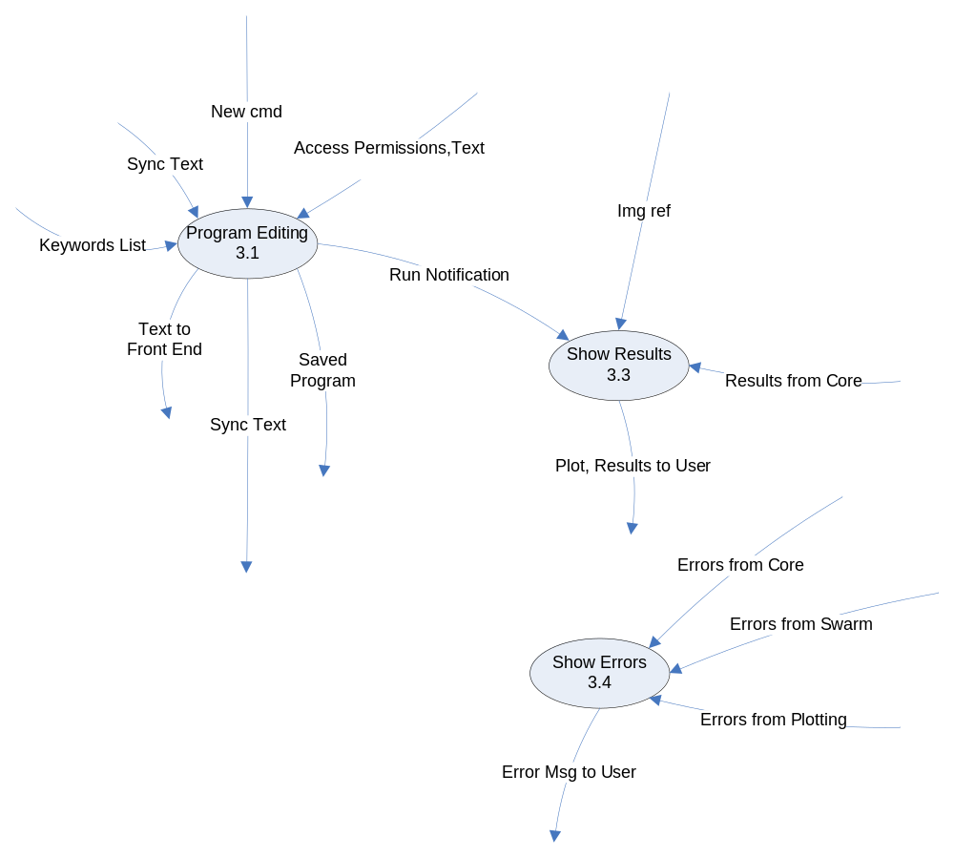
Figure 2: Data Flow Diagram 2

Program Editing
This module is used to perform editing of program text. The editing can only be done if program is not running.

Input
- text and access permissions from program configuration process.
- Sync text from swarm module which consists of text from collaborators.
- New Cmd to create new program.
- Keywords list from front end module which has list of key words supported by SPINACH.

Processing
The program editing shall receive New Cmd from program Configuration and set the appropriate environment for a new program. It shall receive access permissions from program configuration process, and accordingly load text in the new program window. The program editing process shall also send/receive sync text to/from swarm module. It shall reflect instant changes from all collaborators with one distinct color per collaborator. The Program Editing receives a list of keywords from the Front End Module and shall highlight them in the program. It shall support optional line numbering. Horizontal and vertical scroll bars shall be provided, and the user shall have the facility for optional line wrap. The Program Editing Process shall then send the program text to the Front End Module. It shall provide a save button which when clicked saves the program text to the local file system. It shall send run notification to the Show Result Process, when the user clicks on the Compute Button provided on the window.

Output
- Program text to front end.
- Sync text
- Saved programs.
- Run notification to show results process.

Show Results
This process displays to the user the final results that have been computed by SPINACH.

inputs
- Run Notification given by the user
- Results from Core Module
- Reference to the plot’s image from Plotting Module.

processing
This Process shall provide a text box to display the results received from the Core Module. On clicking the Show Plot menu item, the Show Results process shall show the image containing the plots whose reference has been provided by the Plotting Module, on clicking on the “Show Plot” Menu Item. A save button shall be provided to save the plots.

outputs
- Final computed results to user.
- Plot

Show Errors

inputs
- It receives errors from Core, Swarm and Plotting Module.(3 lines)

processing
A pop-up shall come up to show errors to the users. There shall be an error message in the pop up along with some details about the error.

outputs
- Displays Error message to the user

Data Dictionary

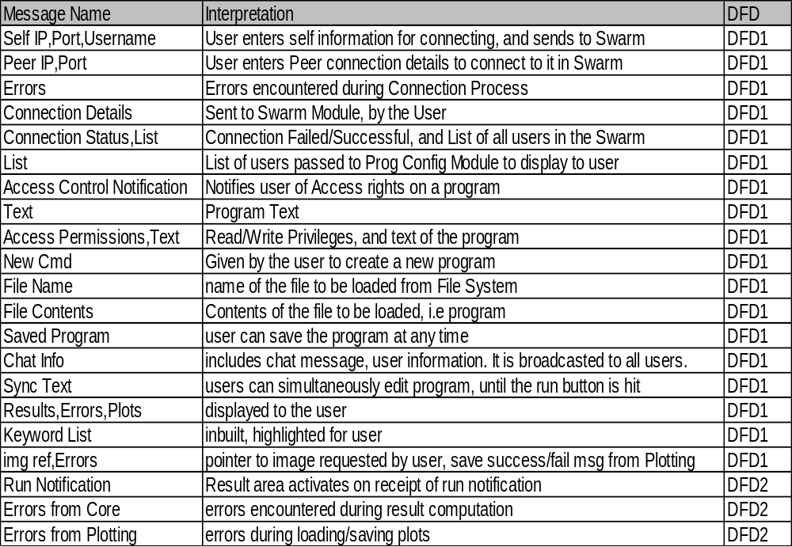
Figure 3 – Data Dictionary

Requirements Traceability Matrix
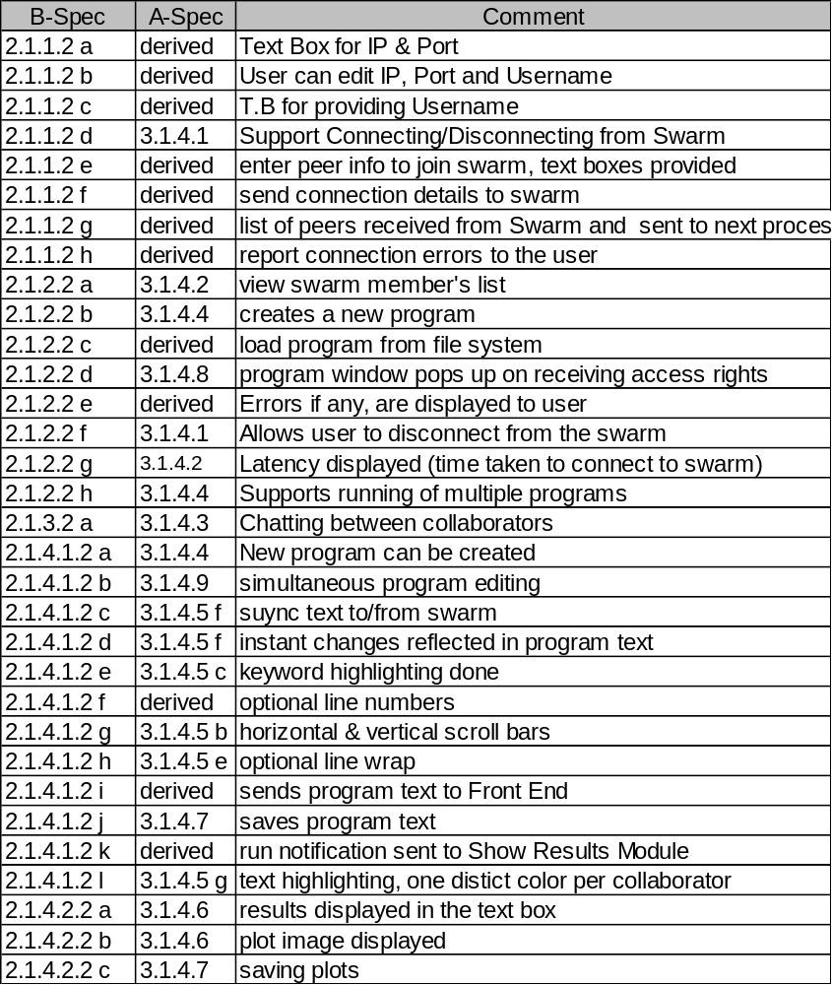
Figure 4 - Requirements Traceability Matrix

